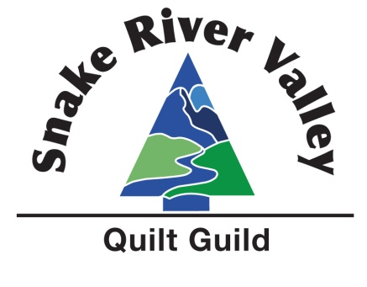
Snake River Valley Quilt Guild
General Meeting Minutes
January 15, 2026
Submitted by Robin Gibbons
Approved
Call to Order:
Guild president, Christy Christensen, called the meeting to order at 6:30 PM.

Minutes: A motion was made to approve the minutes from November 20th, 2025, meeting by Candace seconded by Toni, and passed by a vote of the membership.

Business & Announcements:
Christy welcomed all to meeting and introduced the 2026 board. Thanked the outgoing board members.
Welcomed all guests and asked them to pass the fat quarter basket and take one. Also asked those who were celebrating a birthday this month to grab one as well.

There will be a get together on January 31st from 10:00 am to 4ish at Jones Sew N’ Vac to make new name tags or create one for new members. All members welcome. Please bring your own lunch.

Workshop:
The money is due for the Laura Heine collage class being held March 21st and 2nd. Class will be from 9 to 4 both days with a short lunch break at noon. Christy has examples of what is needed for the workshop on the table on the stage and Celia has printouts of supplies needed. Granny’s fabric house is up front with kits for purchase if you wish.

Community Support:
Christy has proposed two challenges to the guild this year.
- Stack the quilts: 100 quilts to be donated by the end of the year.
- 2026 service hours in 2026: this is a tracking of hours per month of service. For example, piecing for a charity quilt, quilting one, binding one, teaching, holding a sew in for charity quilts and even outside guild hours. Track your hours with a form that Christy has to pick up and deliver at guild meetings. Milestones will be tracked with a small giveaway when reached.

Secret Quilter:
Susan Collins has forms that can still be filled out at the meeting but tonight is the last chance to sign up. Commitment is 4 to 5 gifts minimum through the year. There will be a table in the back to place gifts at guild. For those who have already signed up she has envelopes for in the back.

Intraguild:
Shanna has intraguild folders for those who have paid for dues tonight. If you have your folder and there is a sticker on the inside, please come pick out a fat quarter.

Julie has won the Winter Blue fat quarter swap.

Serena is the winer of the Black and White Raffle block this month.

Shanna showed the February raffle block and will post the tutorial on the SRVQG Facebook group.

Shanna went over upcoming intra guild activities in the folder.

BREAK

Name tag drawing was won by Pam

Reminder that there is a Zoom meeting for the workshop On February 3rd at 7 pm.

Christy asked how many people were planning on coming to the name tag sew along on the 31st. Ten people raised their hands. Money is due THIS month due to the Zoom Meeting. Please contact Celia to pay on another date if you cannot tonight.

The February “Sisters” workshop has been cancelled.

Membership:
Guests: Tammi Wilkins, Denise Brown, Karen Roop, Kathy Davidson, Hildee Foster, Nari Mendenhall, Amanda Fair

New members: Tammi Wilkins, Karen Roop, Nari Mendenhall, Amanda Fair

Education:
Representatives from two of the groups the guild has donated to for the last couple of years came to speak. One from The Nest, and two from Sheppard’s Inn.

Show and tell:
Renee Estrada, Steve Schmid, Jodie Vee, Cathy Squires, Toni Larson, Marilyn Vest, Becky Harvey, Karen McComas, Wendy Skinner, Hildee Foster, Wyatt Foster, Crystal Foster.

Raffle Conducted by: Katie Cowling

Adjournment: The meeting was adjourned at 8:13 PM.

